Microservice  
with Spring Boot



Your Name  
4th September, 20XX

# SOA

SOA emerged as an approach to combat the challenges of large, monolithic applications. It is an architectural style that focuses on organizing software systems as a collection of loosely coupled, interoperable services. It provides a way to design and develop large-scale applications by decomposing them into smaller, modular services that can be independently developed, deployed, and managed.

|  |  |
| --- | --- |
| * Pros   + Reusability of services   + Better maintainability   + Higher reliability   + Parallel development * Cons   + Complex management due to communication protocols (e.g., SOAP)   + High investment costs due to vendor in middleware   + Extra overload |  |

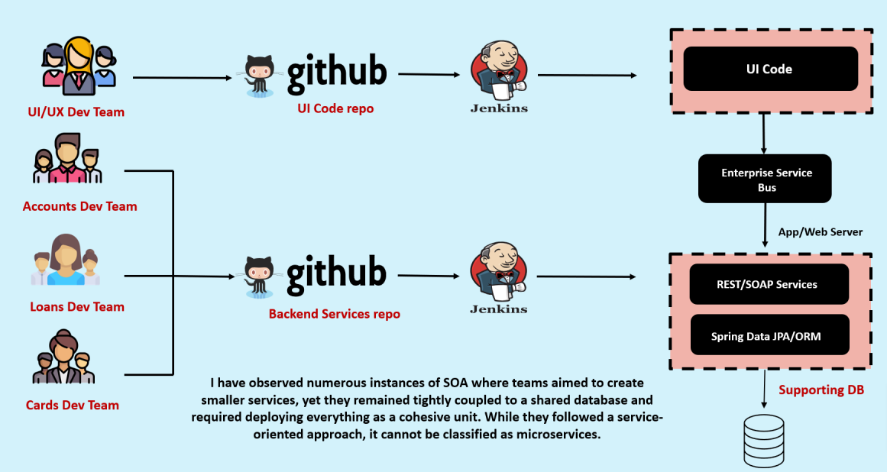

# Microservice Characteristics

Microservices is an approach to developing a single application as a suite of small services, each running in its own process and communicating with lightweight mechanisms, built around business capabilities and independently deployable by fully automated deployment machinery.

Features for MS

* Loosely coupled
* Developed independently
* Deployed independently
* Scaled independently
* Code and configuration maintainer separately
* Microservices must talk to each other
  + Synchronously- HTTP call
  + Asynchronous- Message broker Kafka/RabbitMQ

Key Component

* API gateway
* Service registry
* Config server
* Distributed tracing

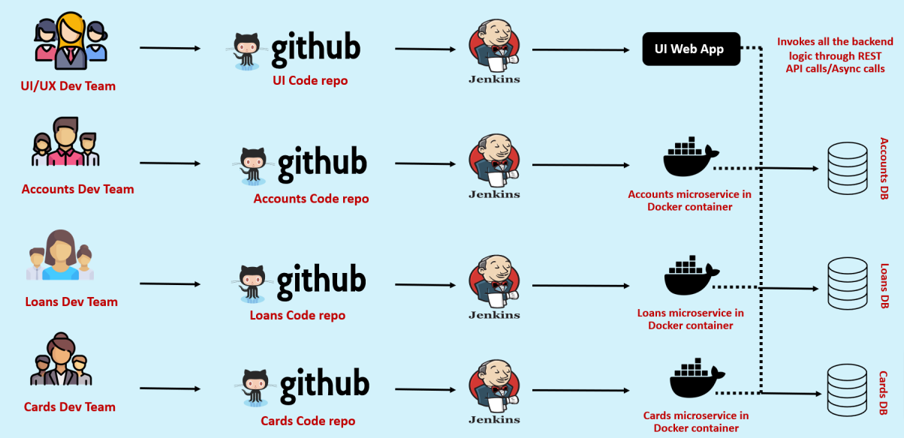

# Cloud Native Applications

Cloud-native applications are software applications designed specifically to leverage cloud computing principles and take full advantage of cloud-native technologies and services. These applications are built and optimized to run in cloud environments, utilizing the scalability, elasticity, and flexibility offered by the cloud.

The engineering team at Heroku cloud platform introduced the 12-Factor methodology, a set of development principles aimed at guiding the design and construction of cloud-native applications. These principles are the result of their expertise and provide valuable insights into building web applications with specific characteristics:

1. **Cloud Platform Deployment:** Applications designed to be seamlessly deployed on various cloud platforms.
2. **Scalability as a Core**: Architectures that inherently support scalability.
3. **System Portability**: Applications that can run across different systems and environments.
4. **Enabling Continuous Deployment and Agility**: Facilitating rapid and agile development cycles.

These principles were developed to assist developers in building effective cloud-native applications, emphasizing the key factors that should be considered for optimal outcomes.

Subsequently, Kevin Hoffman expanded upon the original factors and introduced additional ones in his book, "Beyond the Twelve-Factor App" This revised approach, referred to as the 15-Factor methodology, refreshing the content of the original principles and incorporates three new factors.

1. **One codebase, one application** One-to-one correspondence between an application and its codebase, meaning each application has a dedicated codebase. Shared code is managed separately as a library, allowing it to be utilized as a dependency or as a standalone service, serving as a backing service for other applications. It is possible to track each codebase in its own repository, providing flexibility and organization.

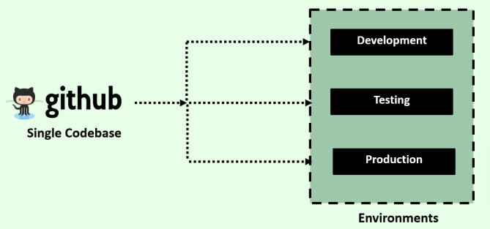

1. **API first** This approach treats APIs as the foundation of the software, rather than building them later
2. **Dependency management**
3. **Design, build, release, run**

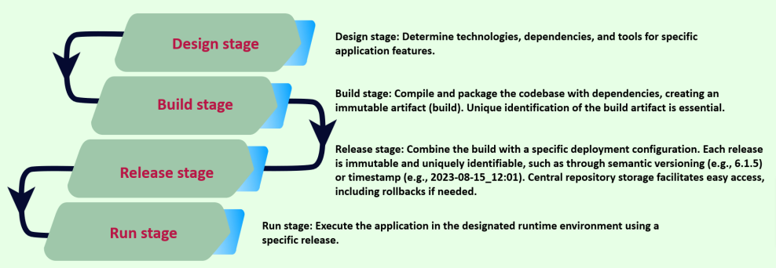

1. **Configuration, credentials & code** To comply with this principle, configuration should not be embedded within the code or tracked in the same codebase, except for default configuration, which can be bundled with the application. Other configurations can still be managed using separate files, but they should be stored in a distinct repository.

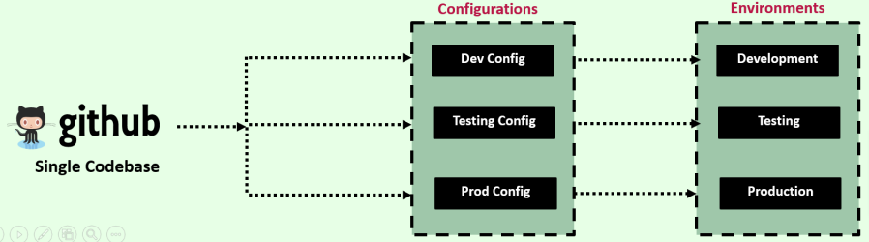

1. **Logs** In a cloud-native application, log routing and storage are not the application's concern. Instead, applications should direct their logs to the standard output, treating them as sequentially ordered events based on time. The responsibility of log storage and rotation is now shifted to an external tool, known as a log aggregator. This tool retrieves, gathers, and provides access to the logs for inspection purposes.

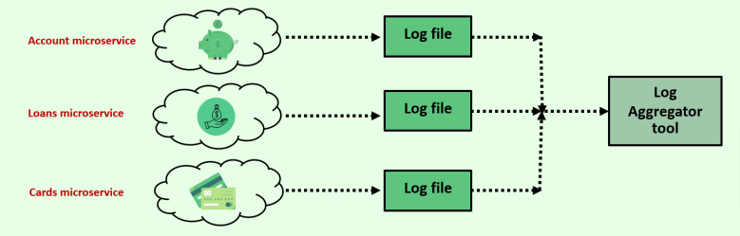

1. **Disposability** Applications in the cloud are considered ephemeral, meaning that if a failure occurs and the application becomes unresponsive, it can be terminated and replaced with a new instance. Similarly, during high-load periods, additional instances of the application can be spun up to handle the increased workload. This concept is referred to as application disposability, where applications can be started or stopped as needed.
2. **Backing services** Backing services refer to external resources that an application relies on to provide its functionality. These resources can include databases, message brokers, caching systems, SMTP servers, FTP servers, or RESTful web services. By treating these services as attached resources, you can modify or replace them without needing to make changes to the application code.
3. **Environment parity**
4. **Administrative processes**
5. **Port binding**
6. **Stateless processes**
7. **Concurrency**
8. **Telemetry**
9. **Authentication & authorization**

# Configuration Management

## Config Server

With Config server we maintain configuration in external Service. We need to add config server dependency

<dependency>  
 <groupId>org.springframework.cloud</groupId>  
 <artifactId>spring-cloud-config-server</artifactId>  
</dependency>

*@SpringBootApplication  
@EnableConfigServer  
public class* ConfigServerApplication {  
 *public static void* main(String[] args) {  
 SpringApplication.run(ConfigServerApplication.*class*);  
 }  
}

Config server supports multiple kinds of source for reading config

Reading from GIT

spring.profiles.active=git  
spring.cloud.config.server.git.uri=https://github.com/justamitsaha/configurations.git  
spring.cloud.config.server.git.default-label=main  
spring.cloud.config.server.git.timeout=5  
spring.cloud.config.server.git.clone-on-start=true  
spring.cloud.config.server.git.force-pull=true

Reading from classpath

spring.profiles.active=native  
spring.cloud.config.server.native.search-locations=classpath:/config

Reading from location

spring.cloud.config.server.native.search-locations="file:///Users//folder//Documents//config"

**Client-Side changes**

<dependency>  
 <groupId>org.springframework.cloud</groupId>  
 <artifactId>spring-cloud-starter-config</artifactId>  
</dependency>

If we don’t provide optional then in case the config server is not started the client service will fail and won’t start. In prod settings when client is dependent on congig server its better to not keep optional, so that developers know the issue during service startup

spring.config.import=optional:configserver:http://localhost:8071/  
spring.profiles.active=prod

If we want to provide default values of the variables we should provide them with the client application.properties, because otherwise the service will fail if it doesn’t get the values. Anyways the config server will overwrite the values from application.properties

*@Value*("${api.info}")  
*private* String buildVersion;

api.info=Product API local  
accounts.message=Welcome to Buying and Selling product Local config  
accounts.contactDetails.name=John Doe - Developer Local  
accounts.contactDetails.email=john@mailinator.com local  
accounts.onCallSupport=(555) 555-1234, (555) 523-1345

*@ConfigurationProperties*(prefix = "accounts")  
*public class* CompanyContactInfoDto {

## Refresh information

Microservice will fetch the config information only during startup and will catch it. If we want to update it during runtime, we have to use actuator

<dependency>  
 <groupId>org.springframework.boot</groupId>  
 <artifactId>spring-boot-starter-actuator</artifactId>  
</dependency>

management.endpoints.web.exposure.include=*

But other microservices have already cached the information during start-up. We can refresh the information using the actuator. We can go to the actuator endpoint of each microservice <http://localhost:8071/actuator> . It will have many endpoints. One of them will be that of refresh <http://localhost:8071/actuator/refresh> . If we invoke this endpoint with POST after that the value will change in microservice without restarting.

Now when we fetch configuration using config server it will return the latest value from Git instead of fetching values from cache. Please note the auto refresh of config server doesn’t work if we use native profile or from class path, **it works only when we fetch information from GIT**

* Change the value in GIT
* Optional step, verify if the values has changed by checking in Config server endpoints like

<http://localhost:8071/identity-service/prod>

or

<http://localhost:8071/identity-service/default>

based on which profile we want to load

* Now update the config by hitting

POST <http://localhost:8080/auth/actuator/refresh>

Updating the refresh endpoint of Config server will not update it

POST <http://localhost:8071/actuator/refresh>

## Encryption Config server

Encrypt sensitive element in Github

* Set an encrypted key in config server properties

encrypt:

encrypt.key=45D81EC1EF61DF9AD8D3E5BB397F9

* After we set key config server will provide encrypt and decrypt URI

<http://localhost:8071/encrypt>

<http://localhost:8071/decrypt>

* With encrypt API we send the data we want to encrypt say email

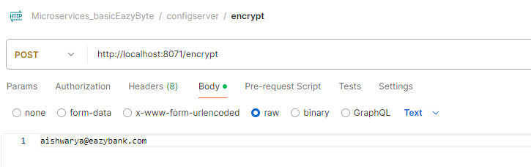

* Once we get the encrypted value we can set it in Github like below. To let config server know this is encrypted we pass keyword cipher

api.info=Product API Prod Config  
accounts.message=Welcome to Buying and Selling product local from config server prod  
accounts.contactDetails.name=John Doe - Developer  
accounts.contactDetails.email={cipher}f5a08fe2d89da3c88f7850a3483641bb69e7cad85890e9a051c3b07b1b11c708  
accounts.onCallSupport=(555) 555-1234, (555) 523-1345

* Decryption can be done like this

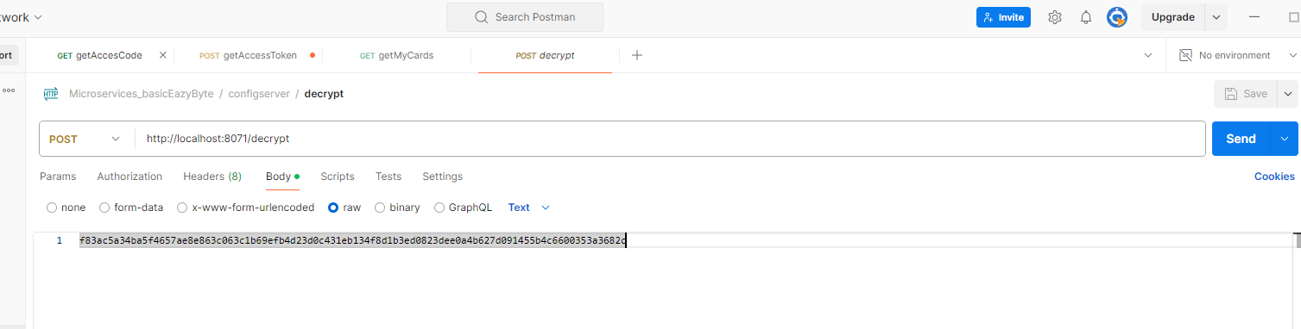

How the encryption process works.

1. Network team can prevent decrypt URL to be accessed by everyone and only microservice application can access it
2. Infra team will pass the encryption KEY as env parameter or CLI from jenkins.
3. Admin who has the sensitive information encrypts using encrypted endpoints and sets the encrypted value in github.
4. The config server can decrypt the sensitive information using the secret key and pass it to microservices. This endpoint can be accessed only by microservice as the URL is restricted for other users

## Auto Refresh cache

Actuator is a good option to update configuration. But we may have hundreds of microservice and each may have hundreds of instances. If we want to manually update the information it may take a lot of manual work and we may miss a few pods leading to inconsistency. Also, with Kubernetes we will have pods and won’t have access to individual microservices

To overcome this challenge, we need to use a new project inside the spring cloud, which is the spring cloud bus. Spring cloud bus links all the nodes of a distributed system with a lightweight message broker. And this can be used to broadcast the state changes, for example, configuration changes or any other management instructions. So whenever you are using the spring cloud bus behind the scenes this spring cloud bus is going to interlink all your microservices instances with a lightweight message broker like Rabbitmq or Kafka. With this, the advantage is you need to invoke a bus refresh api path available against your actuator only one time for one of the instances.

If there are 500 instances running inside your production, you don't have to invoke the actuator refresh api for all your 500 instances. Instead, you can simply invoke the bus refresh API for any of the instances inside this total 500 instances. With that, the spring cloud bus will take care of communicating the changes happening on the spring cloud config server to all other nodes or the instances connected to the same message broker like Rabbitmq?

How to implement

* Install rabbit MQ using docker
* Add dependency related to Spring cloud bus and rabbit MQ in All microservice including config server, below will add both
* Then make sure actuator endpoint is enabled

<dependency>  
 <groupId>org.springframework.cloud</groupId>  
 <artifactId>spring-cloud-starter-bus-amqp</artifactId>  
</dependency>

management.endpoints.web.exposure.include=*

* Then add the location of RabbitMQ

rabbitmq.host=localhost  
rabbitmq.port=5672  
rabbitmq.username=guest  
rabbitmq.password=guest

* Then we need to hit the endpoint <http://localhost:8080/actuator/busrefresh> with POST. If we hit it for one endpoint all instance of all API will get the change

If we want no manual update and update of config on the push of code to github then we have to use a web hook. For this on top of previous change we need to add spring cloud config monitor in config server only.

<dependency>  
 <groupId>org.springframework.cloud</groupId>  
 <artifactId>spring-cloud-config-monitor</artifactId>  
</dependency>

This will add a new API path /monitor. This is not part of the actuator. Using this monitor API path available inside the Spring Cloud Config server, we can create a webhook inside the GitHub repo saying that whenever a change happens inside GitHub repo, like a new property is added, please invoke the monitor API path. As soon as this monitor API path receives a webhook request from the GitHub repo, behind the scenes it is going to invoke the refresh event with the help of Spring Cloud Bus and RabbitMQ.

Changes in git hub

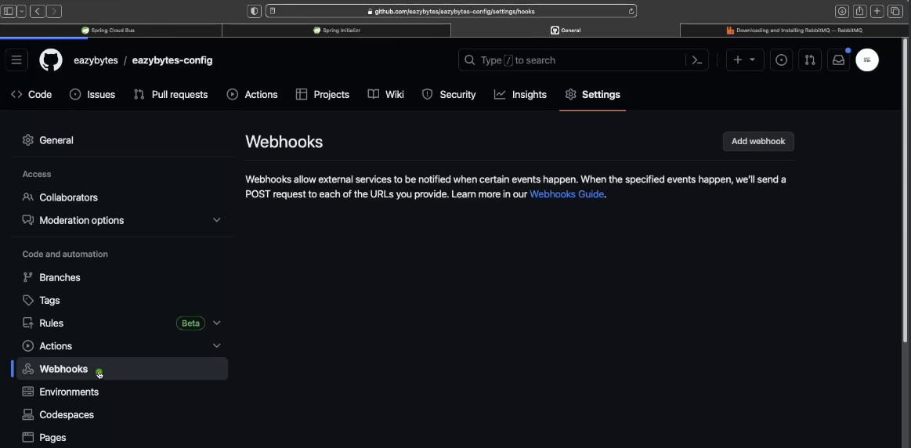

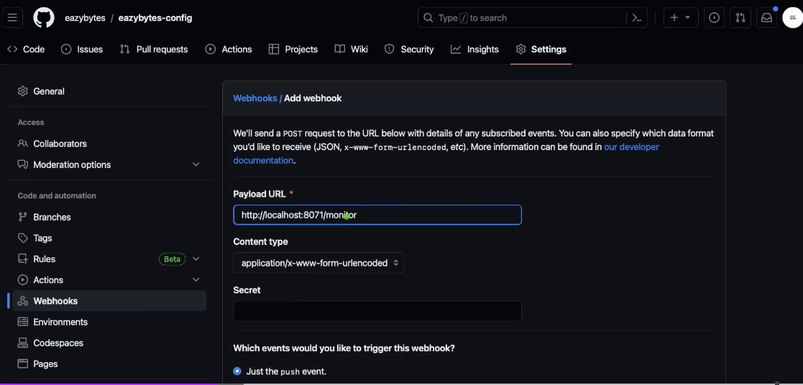

This will not work for local host so we can try hookdeck.com

## Liveness Readiness

When we are going to deploy our microservices, our applications as Docker containers and these containers, we don't have to manually monitor them and we don't have to manually handle the scaling or elasticity requirements. Instead, container orchestration products like Kubernetes, they are going to handle that. So to handle these containers effectively, platforms like Kubernetes or even Docker, they need to understand whether my running container is working without any issues and the health of my running container is fine. They will try to understand whether my container is running properly. If not, they will try to make some corrective steps like maybe they will try to restart the container even after restarting the container. If the health probes are not working properly, they will try to create a new container by deleting the existing one and the same.

**Liveness** Aliveness probe sends a signal that the container or application is either alive (passing) or dead (failing). If the container is alive, then no action is required because the current state is good. If the container is dead, then an attempt should be made to heal the application by restarting it. In simple words, liveness answers a true-or-false question: "Is this container alive?"

**Readiness** probe used to know whether the container or app being probed is ready to start receiving network traffic. If your container enters a state where it is still alive but cannot handle incoming network traffic (a common scenario during startup), you want the readiness probe to fail. So , traffic will not be sent to a container which isn't ready for it. If someone prematurely sends network traffic to the container, it could cause the load balancer (or router) to return a 502 error to the client and terminate the request. The client would get a "connection refused" error message. In simple words, readiness answers a true-or-false question: "Is this container ready to receive network traffic?"

Inside Spring Boot apps, the actuator gathers the "Liveness" and "Readiness" information from the Application availability interface and uses that information in dedicated health indicators: LivenessStateHealthIndicator and ReadinessState Health Indicator. These indicators are shown on the global health endpoint ("/actuator/health"). They are also exposed as separate HTTP Probes by using health groups: "/actuator/health/liveness" and "/actuator/health/readiness"

 

We need to know if the config server is live and ready as other servers depend on it . This is done with the help of 2 actuator endpoints /actuator/health/liveness and /actuator/health/readiness. This needs to be enabled in config server properties like below

*#expose Actuator endpoints*management.endpoints.web.exposure.include=*  
*#expose readiness*management.health.readiness-state.enabled=true  
*#expose liveness*management.health.liveness-state.enabled=true  
*#expose endpoint web URL for above*management.endpoint.health.probes.enabled=true

In order to expose the readiness and livelines we need to make below changes in the configserver section of Docker Compose. It hits the health readiness URL of the config server and if it return UP then success otherwise failure

config-server:  
 image: "justamitsaha/ms-config-server:1gateway"  
 container_name: "config-ms"  
 ports:  
 - "8071:8071"  
*# depends_on:  
# rabbit:  
# condition: service_healthy* healthcheck:  
 test: "curl --fail --silent localhost:8071/actuator/health/readiness | grep UP || exit 1"  
 interval: 10s  
 timeout: 5s  
 retries: 10  
 start_period: 10s  
 environment:  
 SPRING_APPLICATION_NAME: "config-server"  
 extends:  
 file: common-config.yml  
 service: microservice-base-config  
  
 discovery-service:  
 image: "justamitsaha/ms-discovery-service:1gateway"  
 container_name: discovery-ms  
 ports:  
 - "8081:8081"  
 healthcheck:  
 test: "curl --fail --silent localhost:8081/discovery/actuator/health/readiness | grep UP || exit 1"  
 interval: 10s  
 timeout: 5s  
 retries: 10  
 start_period: 10s  
 extends:  
 file: common-config.yml  
 service: microservice-base-config  
 environment:  
 SPRING_APPLICATION_NAME: "discovery-service"

## Common Config

There are a lot of common items in Docker compose which are repetitive. We can move them to a common config

services:  
 network-deploy-service:  
 networks:  
 - micro-service  
  
 microservice-base-config:  
 extends:  
 service: network-deploy-service  
 deploy:  
 resources:  
 limits:  
 memory: 700m  
 *# environment:  
 # SPRING_RABBITMQ_HOST: "rabbit"* discovery-gateway-dependency:  
 extends:  
 service: microservice-base-config  
 depends_on:  
 discovery-service:  
 condition: service_healthy  
 environment:  
 EUREKA_CLIENT_SERVICEURL_DEFAULTZONE: http://discovery-service:8081/discovery/eureka/  
  
  
 config-server-config-dependency:  
 extends:  
 service: discovery-gateway-dependency  
 depends_on:  
 config-server:  
 condition: service_healthy  
 environment:  
 SPRING_PROFILES_ACTIVE: default  
 SPRING_CONFIG_IMPORT: configserver:http://config-server:8071/

# Service Discovery

Discovery Server

<spring-cloud.version>2023.0.2</spring-cloud.version>

<dependency>  
 <groupId>org.springframework.cloud</groupId>  
 <artifactId>spring-cloud-starter-netflix-eureka-server</artifactId>  
</dependency>

<dependencyManagement>  
 <dependencies>  
 <dependency>  
 <groupId>org.springframework.cloud</groupId>  
 <artifactId>spring-cloud-dependencies</artifactId>  
 <version>${spring-cloud.version}</version>  
 <type>pom</type>  
 <scope>import</scope>  
 </dependency>  
 </dependencies>  
</dependencyManagement>

Will also need actuator as it uses actuator endpoints to do health checks

<dependency>  
 <groupId>org.springframework.boot</groupId>  
 <artifactId>spring-boot-starter-actuator</artifactId>  
</dependency>

@SpringBootApplication  
@EnableEurekaServer  
public class DiscoveryServiceApplication {  
 public static void main(String[] args) {  
 SpringApplication.run(DiscoveryServiceApplication.class, args);  
 }  
}

spring.application.name=discovery-service  
server.port=8081  
server.servlet.context-path=/discovery  
  
eureka.instance.hostname=localhost  
eureka.client.fetchRegistry=false  
eureka.client.registerWithEureka=false  
eureka.client.serviceUrl.defaultZone=http://${eureka.instance.hostname}:${server.port}/discovery/eureka/  
  
#expose Actuator endpoints  
management.endpoints.web.exposure.include=*  
#expose readiness  
management.health.readiness-state.enabled=true  
#expose liveness  
management.health.liveness-state.enabled=true  
#expose endpoint web URL for above  
management.endpoint.health.probes.enabled=true

On client side

<dependency>  
 <groupId>org.springframework.cloud</groupId>  
 <artifactId>spring-cloud-starter-netflix-eureka-client</artifactId>  
</dependency>  
  
<dependency>  
 <groupId>org.springframework.boot</groupId>  
 <artifactId>spring-boot-starter-actuator</artifactId>  
</dependency>

<dependencyManagement>  
 <dependencies>  
 <dependency>  
 <groupId>org.springframework.cloud</groupId>  
 <artifactId>spring-cloud-dependencies</artifactId>  
 <version>${spring-cloud.version}</version>  
 <type>pom</type>  
 <scope>import</scope>  
 </dependency>  
 </dependencies>  
</dependencyManagement>

<spring-cloud.version>2023.0.2</spring-cloud.version>

spring.application.name=discovery-service  
server.port=8081  
server.servlet.context-path=/discovery  
logging.pattern.console = ${LOGPATTERN_CONSOLE:%green(%d{HH:mm:ss.SSS}) %blue(%-5level) %red([%thread]) %yellow(%logger{15}) - %msg%n}  
  
eureka.instance.hostname=localhost  
eureka.client.fetchRegistry=false  
eureka.client.registerWithEureka=false  
eureka.client.serviceUrl.defaultZone=http://${eureka.instance.hostname}:${server.port}/discovery/eureka/  
  
#expose Actuator endpoints  
management.endpoints.web.exposure.include=*  
#expose readiness  
management.health.readiness-state.enabled=true  
#expose liveness  
management.health.liveness-state.enabled=true  
#expose endpoint web URL for above  
management.endpoint.health.probes.enabled=true

Important URL

<http://localhost:8070/eureka/apps>

If we send header Accept application/json will get as JSON

As soon as my Eureka Server realizes that the majority of the microservices instances are not sending the heartbeat, then it is not going to react and remove all the service instance details from the registry. Instead, it is going to enter a self-preservation mode and once the Eureka Server enters this mode, even if it is not receiving the heartbeat signals from the service instances, it is not going to remove the service details from the service registry. This prevents the Eureka server from evicting all the instances due to some temporary network delays or temporary network glitches. Many times, the network issues can be on the internet provider, or it can be on the cloud provider side, or it can be within the microservice network regardless of where the issue is, after a few minutes or few seconds, the network related issue will automatically resolved. For these kinds of scenarios only, we have these Eureka self-preservation modes. Inside this self-preservation mode. The Eureka Server continues to serve the registered instances to client applications. It suspects that some instances are no longer available.

On a high level the summary is, Eureka Server is not going to panic whenever it is not receiving heartbeats from most of the instances. Instead, it will be calm and enter the self-preservation mode, and it will do the meditation. During the self-preservation mode or during this meditation process, it is not going to evict all the instances from the service registry. This feature is a savior where the network glitches are common and help us to handle the false positive alarms.

# Api Gateway

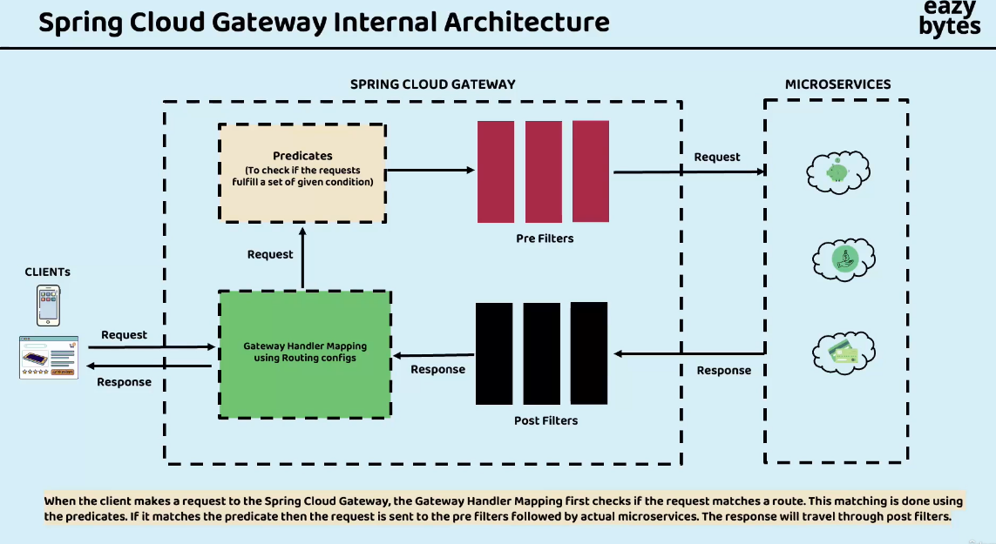

# Circuit Breaker

3 states of circuit breaker

1. Closed → Will continue to send
2. Open – > Will not send request and fail
3. Half Open → In open state it will not stay forever, periodically it will send certain amount of traffic

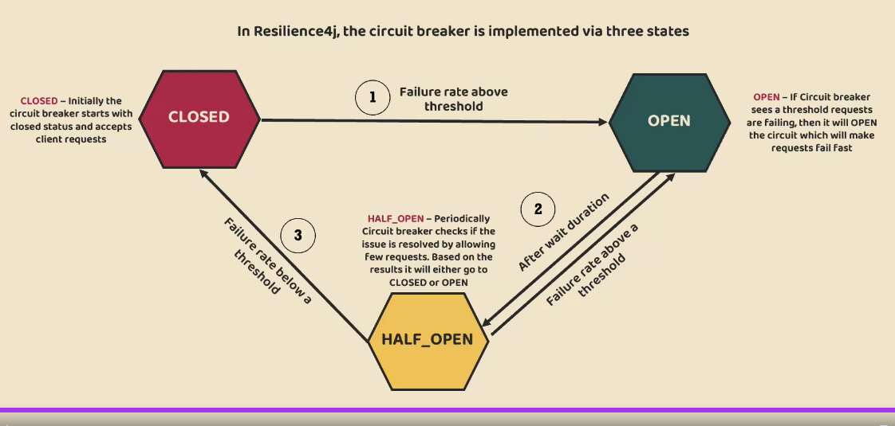

## Circuit Breaker Gateway

<dependency>

<groupId>org.springframework.cloud</groupId>

<artifactId>spring-cloud-starter-circuitbreaker-reactor-resilience4j</artifactId>

</dependency>

Setting circuit breaker in Gateway we can set fallback URL aso

.route(p -> p  
 .path("/auth/**")  
 .filters(gatewayFilterSpec -> gatewayFilterSpec  
 .rewritePath("/auth/(?<segment>.*)", "/identity/${segment}")  
 .circuitBreaker(config -> config.setName("identity-circuit-breaker")  
 .setFallbackUri("forward:/product/configuration/contact-info"))  
 .retry(retryConfig -> retryConfig.setRetries(3)  
 .setMethods(HttpMethod.GET)  
 .setBackoff(Duration.ofMillis(100), Duration.ofMillis(1000), 2, *true*)))  
 .uri("lb://IDENTITY-SERVICE"))

*#monitor 5 request before moving to close from open*resilience4j.circuitbreaker.configs.default.slidingWindowSize=5  
*#send 2 request in half open and decide which state to go open or closed*resilience4j.circuitbreaker.configs.default.permittedNumberOfCallsInHalfOpenState=2  
*#if 50% request are failing then go to open state*resilience4j.circuitbreaker.configs.default.failureRateThreshold=50  
*#Will wait 10 seconds before going to half open*resilience4j.circuitbreaker.configs.default.waitDurationInOpenState=10000

This is default circuit breaker we can give name to circuit breakers and put individual configurations

We can see the circuit breaker configuration fromActuator also

<http://localhost:8080/actuator/circuitbreakers>

But it will work only if we have called the end point once. But will show when we call the endpoint once. So after calling below endpoint the actuator will show circuit breaker

<http://localhost:8080/auth/user/findByEmailContaining/007@mailinator.com>

But not with <http://localhost:8080/authentication/user/findById/1> . Since out circuit breaker is configured with “auth” and not “authentication”

If we set debug point in the API, it will time out and we can see circuit breaker being called

The actuator URL will show the circuit breaker status

{

"circuitBreakers": {

"identity-circuit-breaker": {

"failureRate": "60.0%",

"slowCallRate": "0.0%",

"failureRateThreshold": "50.0%",

"slowCallRateThreshold": "100.0%",

"bufferedCalls": 5,

"failedCalls": 3,

"slowCalls": 0,

"slowFailedCalls": 0,

"notPermittedCalls": 1,

"state": "OPEN"

}

}

}

## Circuitbreaker feign client

If you haven’t used spring reactor use below dependency

</dependency>

<dependency>

<groupId>org.springframework.cloud</groupId>

<artifactId>spring-cloud-starter-circuitbreaker-resilience4j</artifactId>

</dependency>

spring.cloud.openfeign.circuitbreaker.enabled=true

resilience4j.circuitbreaker.configs.default.slidingWindowSize=5

resilience4j.circuitbreaker.configs.default.permittedNumberOfCallsInHalfOpenState=2

resilience4j.circuitbreaker.configs.default.failureRateThreshold=50

resilience4j.circuitbreaker.configs.default.waitDurationInOpenState=10000

We define fall back in the Feign client

@Configuration

@FeignClient(name = "${product.service.feign.configuration.url}", fallback = ProductContactInfoFallback.class)

public interface ProductFeignClient {

@GetMapping("/contact-info")

public ResponseEntity<CompanyContactInfoDto> getContactInfo();

}

In case of error it switches to fallback

@Component

public class ProductContactInfoFallback implements ProductFeignClient {

@Override

public ResponseEntity<CompanyContactInfoDto> getContactInfo() {

return null;

}

}

To test circuit breaker with Feign client put debug point in getContactInfo in ConfigurationController of product service and hit the API <http://localhost:8080/authentication/user/getUserContactInfo/2> . It can go to Feign client or web client, check from identity service logs

When it goes to Feign client we can see "companyContactInfoDto": null is returned

{

"userDto": {

"id": 2,

"name": "Shamit Saha",

"email": "shamit007@mailinator.com",

"phoneNumber": "9999999998",

"role": "SELLER"

},

"companyContactInfoDto": **null**

}

## Timeout:

Time out setup

//if not getting connected in 1 second we are not going to wait and we are going to kill the request.

spring.cloud.gateway.httpclient.connect-timeout=1000

//maximum time for which gateway server will wait to receive the response

spring.cloud.gateway.httpclient.response-timeout=2s

## Retry Pattern

The retry pattern will make configured multiple retry attempts when a service has temporarily failed. This pattern is very helpful in scenarios like network disruption where the client request may successful after a retry attempt. Here are some key components and considerations of implementing the Retry pattern in microservices:

* **Retry Logic**: Determine when and how many times to retry an operation. This can be based on factors such as error codes, exceptions, or response status.
* **Backoff Strategy**: Define a strategy for delaying retries to avoid overwhelming the system or exacerbating the underlying issue. This strategy can involve gradually increasing the delay between each retry, known as exponential backoff.
* **Circuit Breaker Integration**: Consider combining the Retry pattern with the Circuit Breaker pattern. If a certain number of retries fail consecutively, the circuit can be opened to prevent further attempts and preserve system resources.
* **Idempotent Operations**: Ensure that the retried operation is idempotent, meaning it produces the same result regardless of how many times it is invoked. This prevents unintended side effects or duplicate operations.

.route(p -> p

.path("/product/configuration/**")

.filters(gatewayFilterSpec -> gatewayFilterSpec

.rewritePath("/product/configuration/(?<segment>.*)", "/configuration/${segment}")

.retry(retryConfig -> retryConfig.setRetries(3) // Retry 3 times

.setMethods(HttpMethod.GET) // Which operations should we retry

.setBackoff(Duration.ofMillis(100), Duration.ofMillis(1000), 2, true))) //firstBackoff, maxBackoff, next backoff will be in a factor 100 *2, basedOnPreviousValue

.uri("lb://PRODUCT-SERVICE"))

Retry in Individual microservice, here we can define fallback also

@Retry(name = "getBuildInfo",fallbackMethod = "getBuildInfoFallback")

@GetMapping("/build-info")

public ResponseEntity<String> getBuildInfo() {

***logger***.debug("getBuildInfo() method Invoked");

return ResponseEntity

.*status*(HttpStatus.***OK***)

.body(buildVersion);

}

public ResponseEntity<String> getBuildInfoFallback(Throwable throwable) {

***logger***.debug("getBuildInfoFallback() method Invoked");

return ResponseEntity

.*status*(HttpStatus.***OK***)

.body("0.9");

}

resilience4j.retry:

configs:

default:

maxRetryAttempts: 3

waitDuration: 500

enableExponentialBackoff: true

exponentialBackoffMultiplier: 2

ignoreExceptions:

- java.lang.NullPointerException

retryExceptions:

- java.util.concurrent.TimeoutException

## Rate Limiter

So based upon your requirements, you need to provide the details with the help of KeyResolver interface. There is also a default implementation of KeyResolver, which is PrincipalNameKeyResolver. If you are using spring security to secure your microservices, then with the help of these PrincipalNameKeyResolver, it is going to fetch the current logged in user name and accordingly it is going to enforce RateLimiter and by default you can see if the KeyResolver does not find a key, the requests are going to be denied if needed.

Using this Redis, we can implement these RateLimiter in gate way

<dependency>

<groupId>org.springframework.boot</groupId>

<artifactId>spring-boot-starter-data-redis-reactive</artifactId>

</dependency>

@Bean

public RedisRateLimiter redisRateLimiter() {

return new RedisRateLimiter(1, 1, 1);

}

@Bean

KeyResolver userKeyResolver() {

return exchange -> Mono.*justOrEmpty*(exchange.getRequest().getHeaders().getFirst("user"))

.defaultIfEmpty("anonymous");

}

Rate limiter in API

resilience4j.ratelimiter:

configs:

default:

timeoutDuration: 1000

limitRefreshPeriod: 5000

limitForPeriod: 1

## BulkHead Pattern

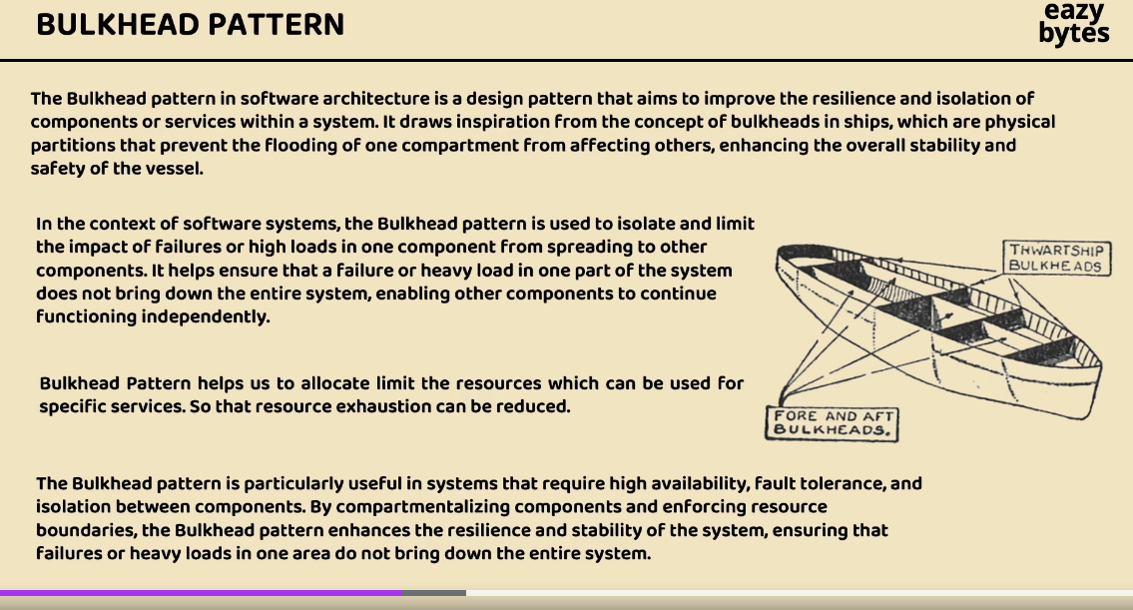

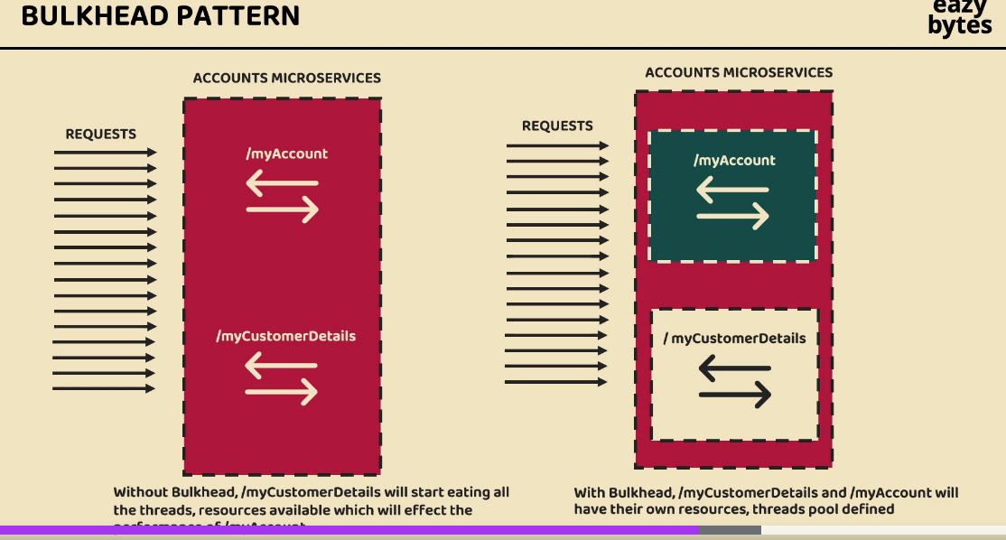

# Security

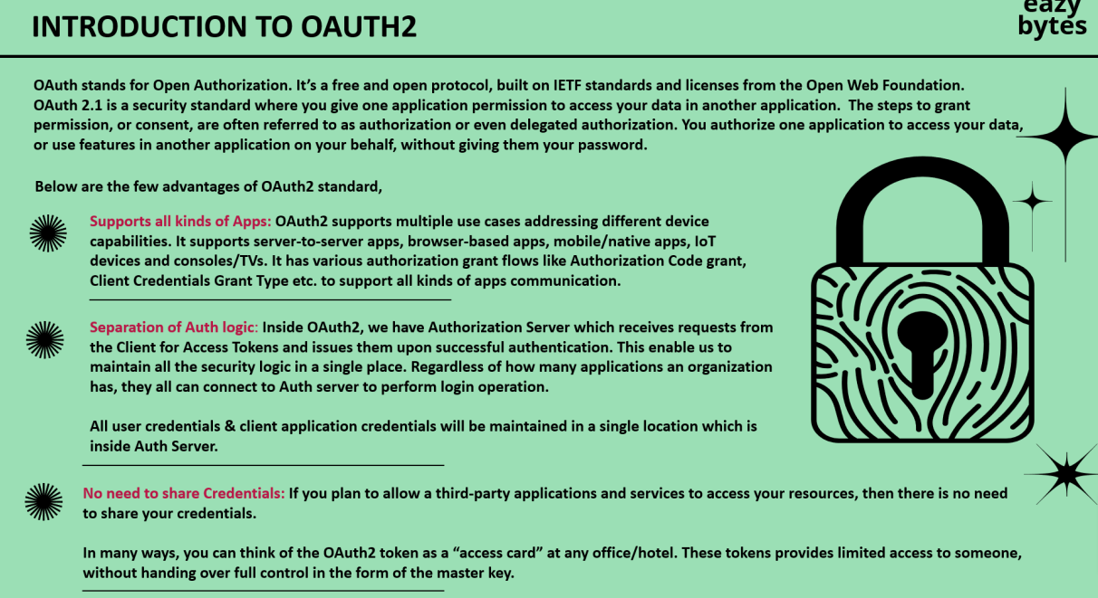

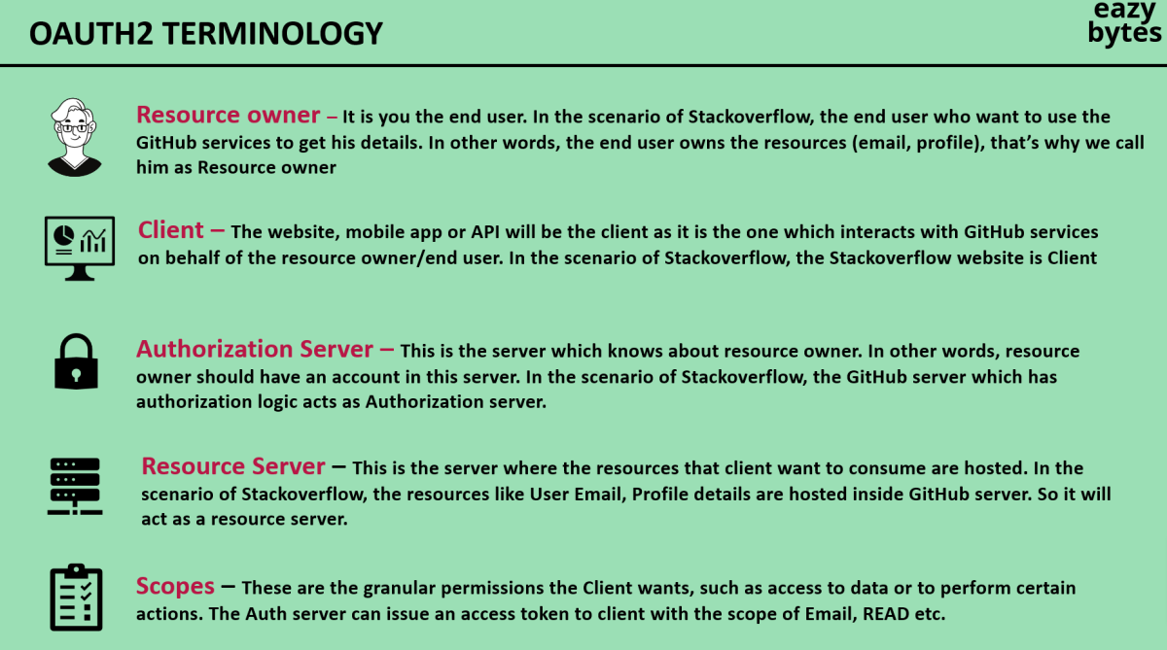

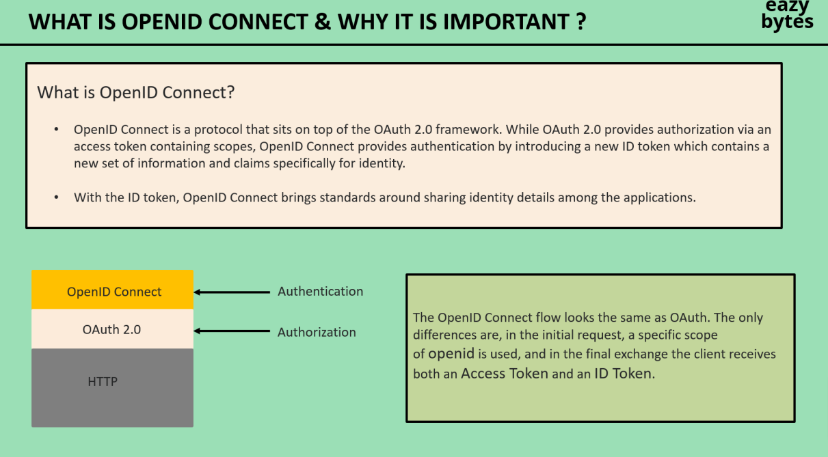

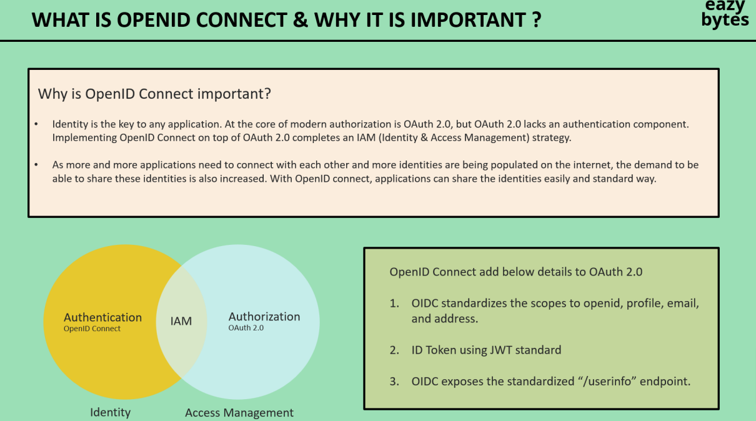

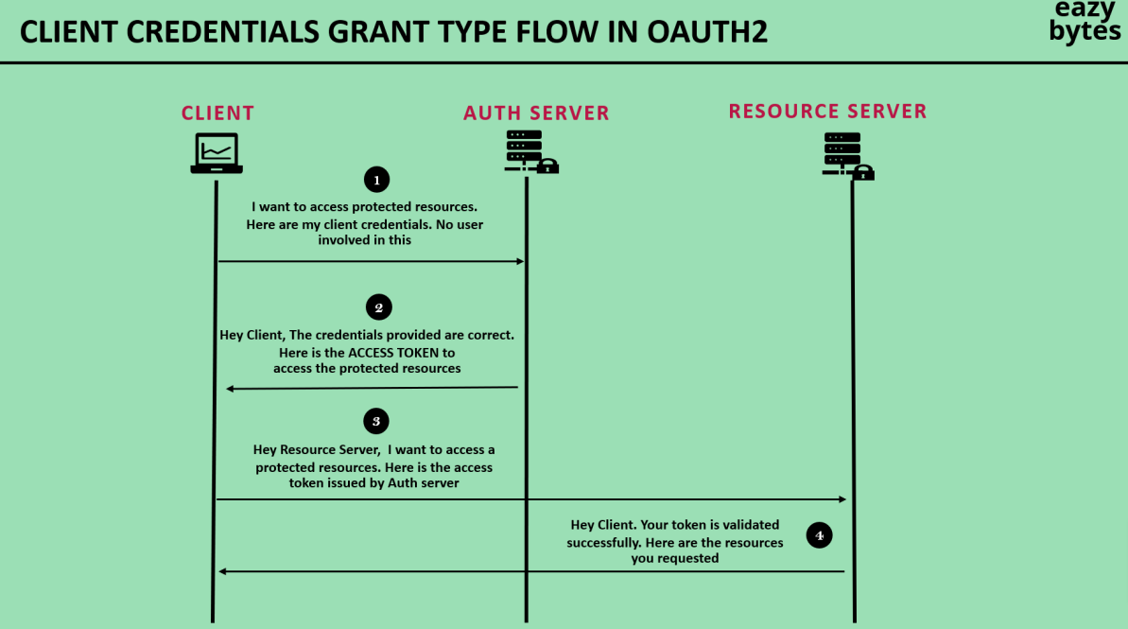

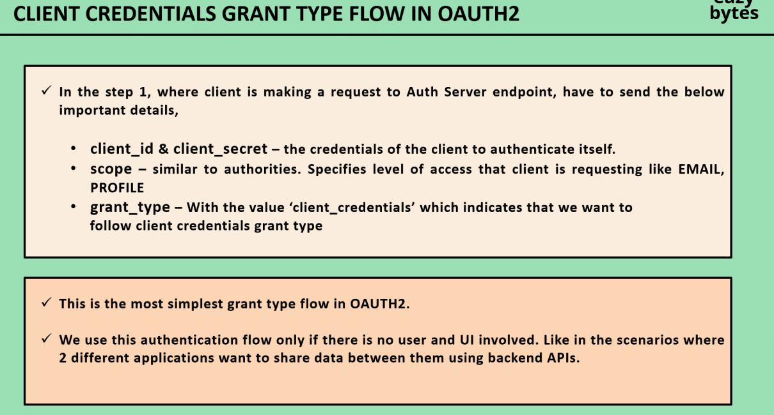

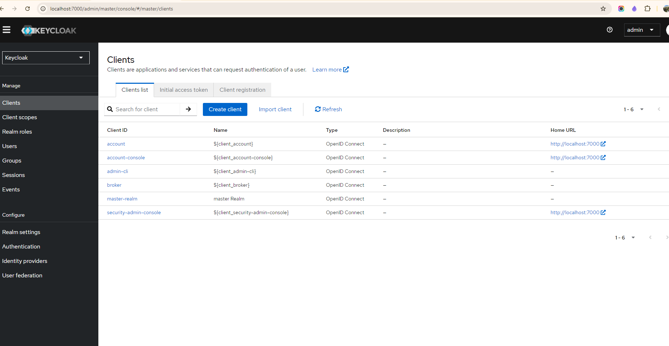

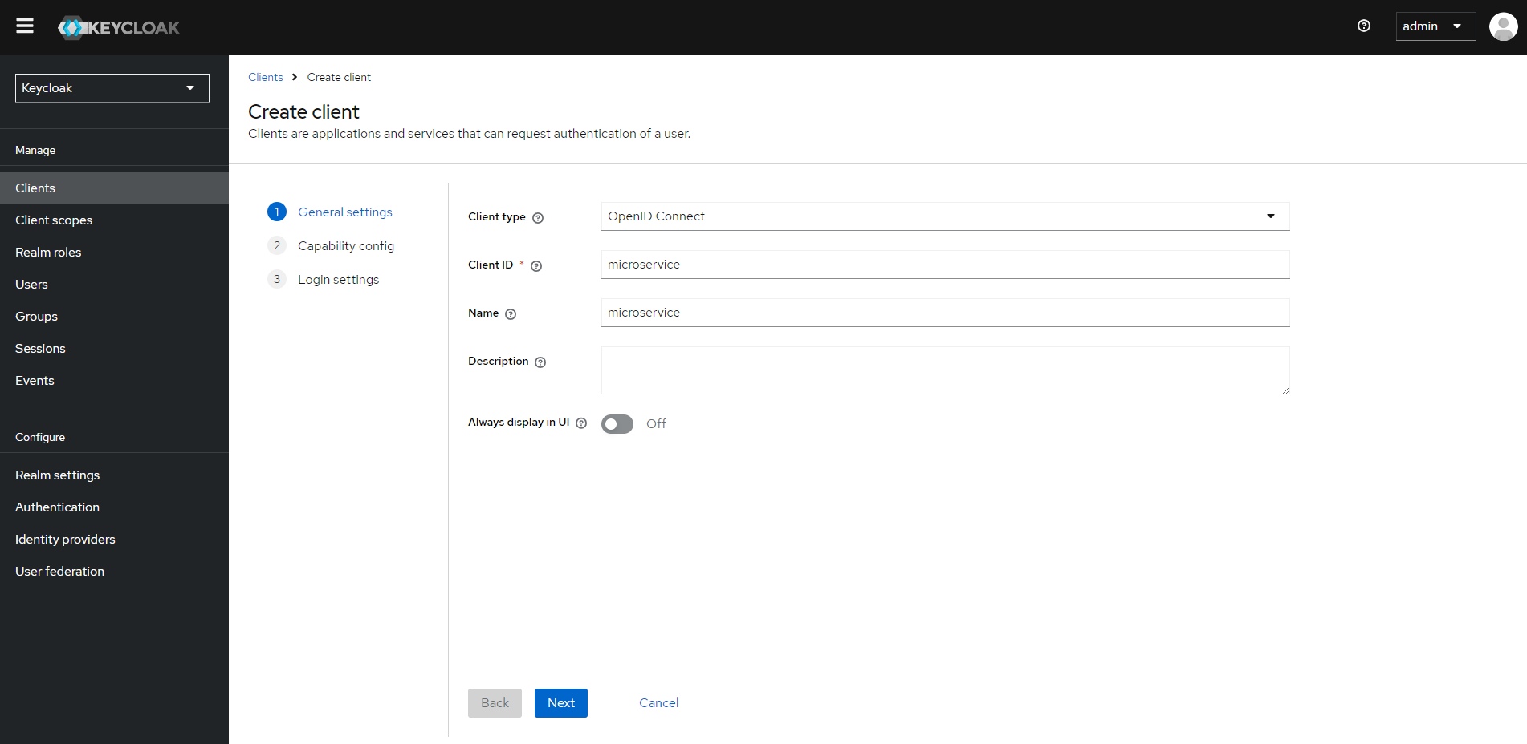

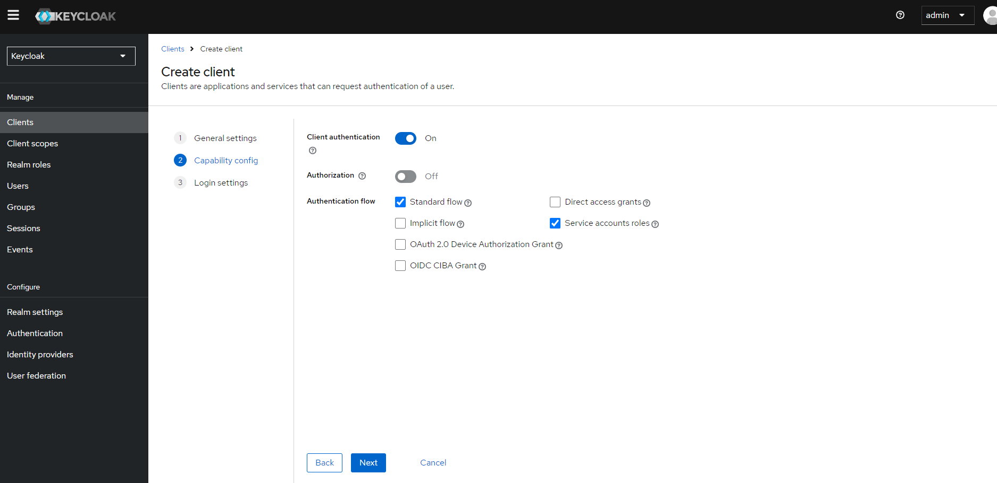

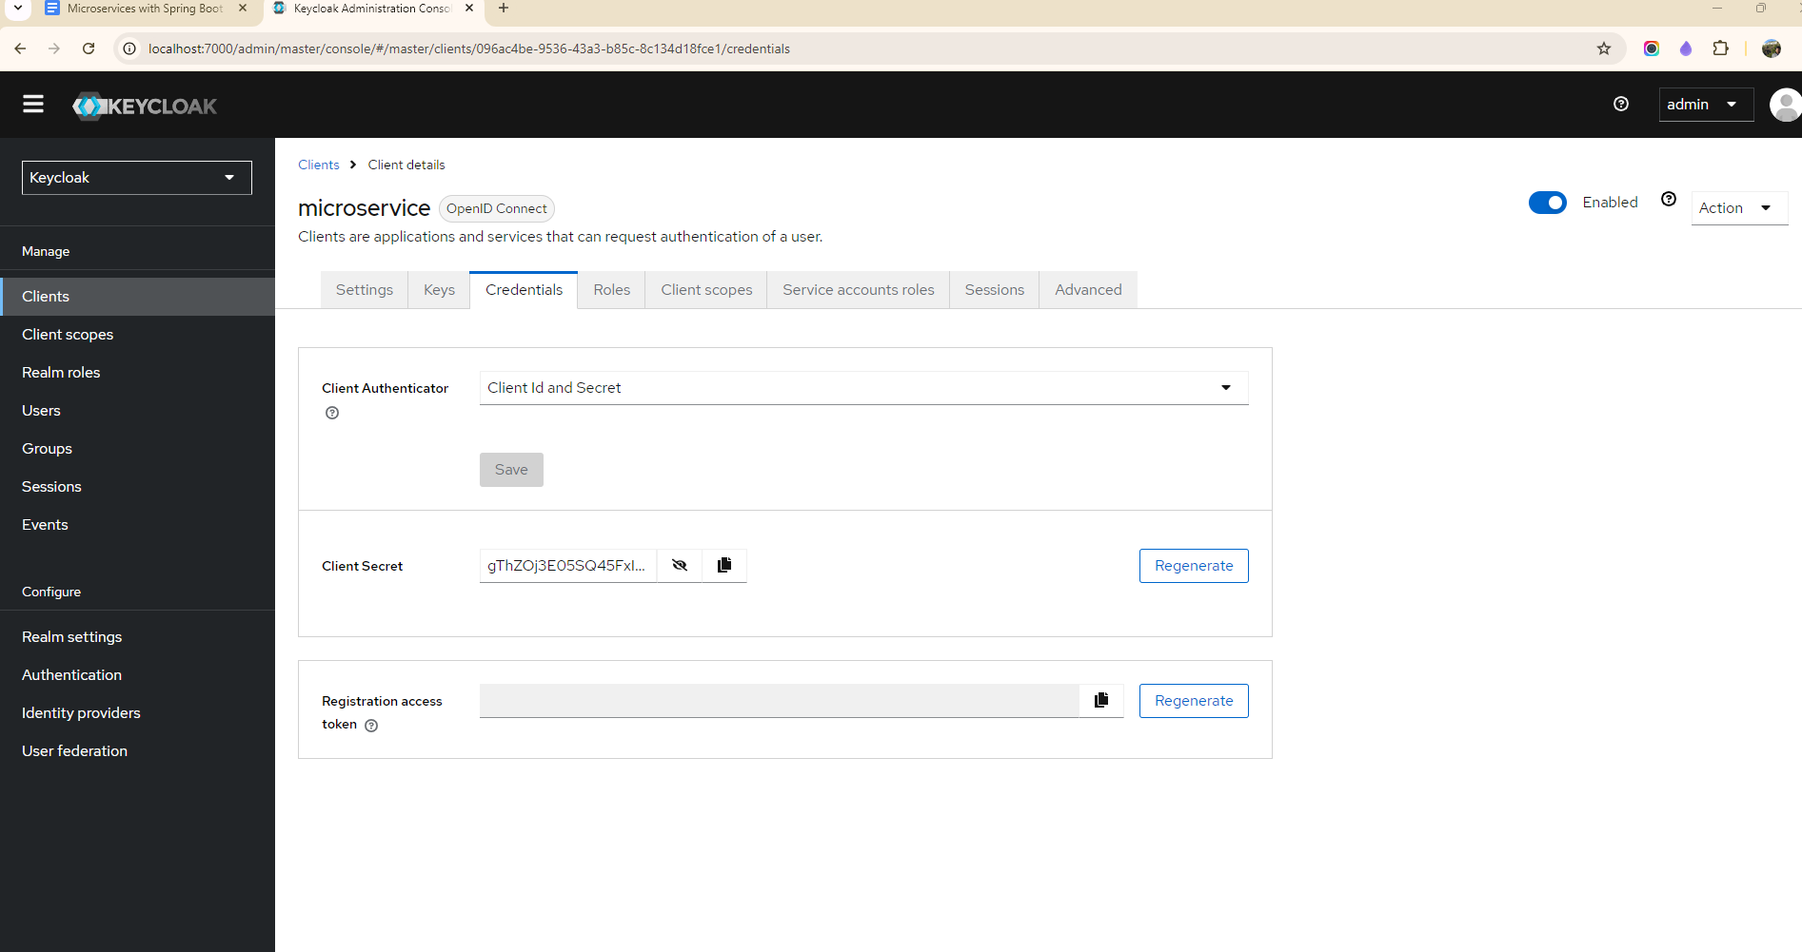

Adding dependency in Gateway server

<dependency>

<groupId>org.springframework.boot</groupId>

<artifactId>spring-boot-starter-security</artifactId>

</dependency>

<dependency>

<groupId>org.springframework.security</groupId>

<artifactId>spring-security-oauth2-resource-server</artifactId>

</dependency>

<dependency>

<groupId>org.springframework.security</groupId>

<artifactId>spring-security-oauth2-jose</artifactId>

</dependency>

Add security configuration in Gateway

@Configuration

@EnableWebFluxSecurity

public class SecurityConfiguration {

@Bean

public SecurityWebFilterChain spSecurityWebFilterChain(ServerHttpSecurity serverHttpSecurity) {

serverHttpSecurity.authorizeExchange(authorizeExchangeSpec ->

authorizeExchangeSpec

.pathMatchers("/actuator/**").permitAll()

.pathMatchers("/authentication/user/private/**").authenticated()

.pathMatchers("/authentication/**").permitAll())

.oauth2ResourceServer(oAuth2ResourceServerSpec -> oAuth2ResourceServerSpec.jwt(Customizer.withDefaults()));

return serverHttpSecurity.build();

}

spring.security.oauth2.resourceserver.jwt.jwk-set-uri=http://localhost:7080/realms/master/protocol/openid-connect/certs

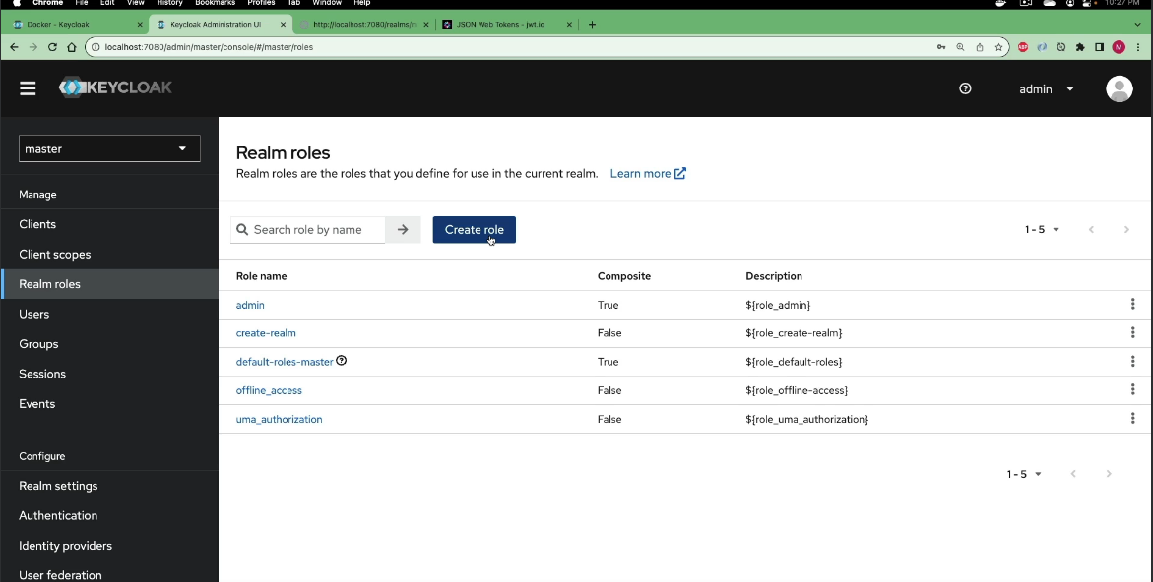

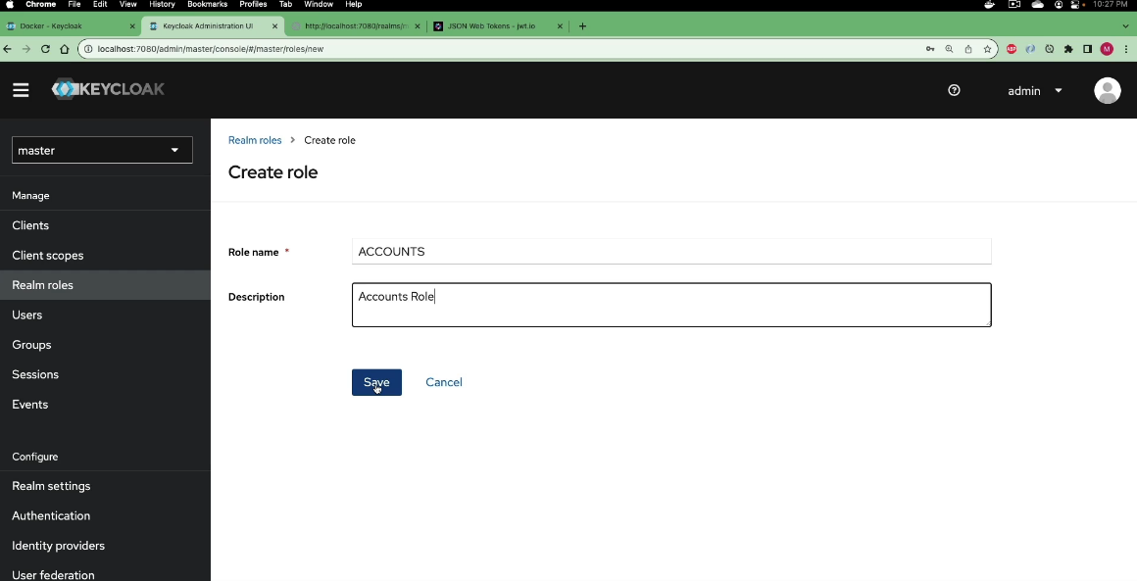

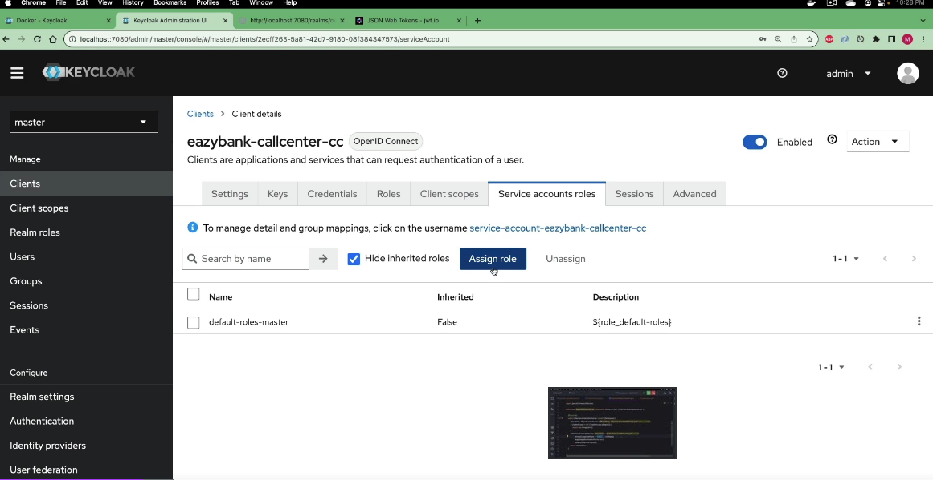

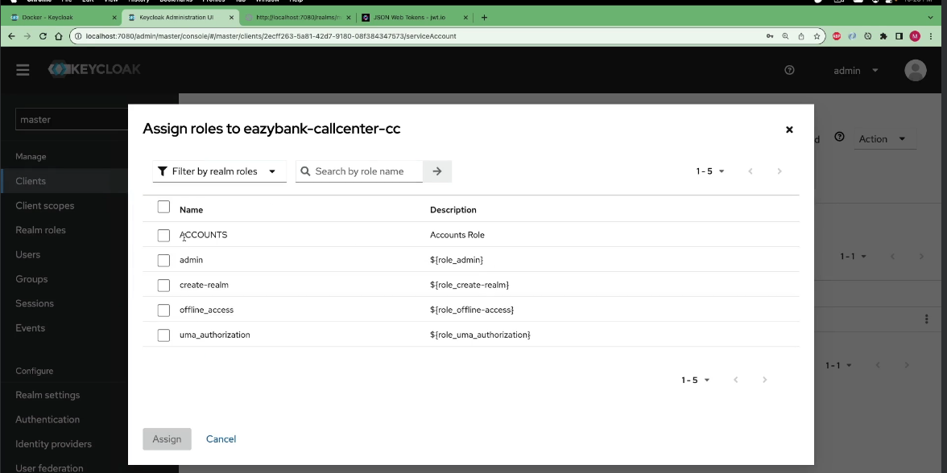

# Event Driven Microservices

# 

# Monitoring and Observability

## 

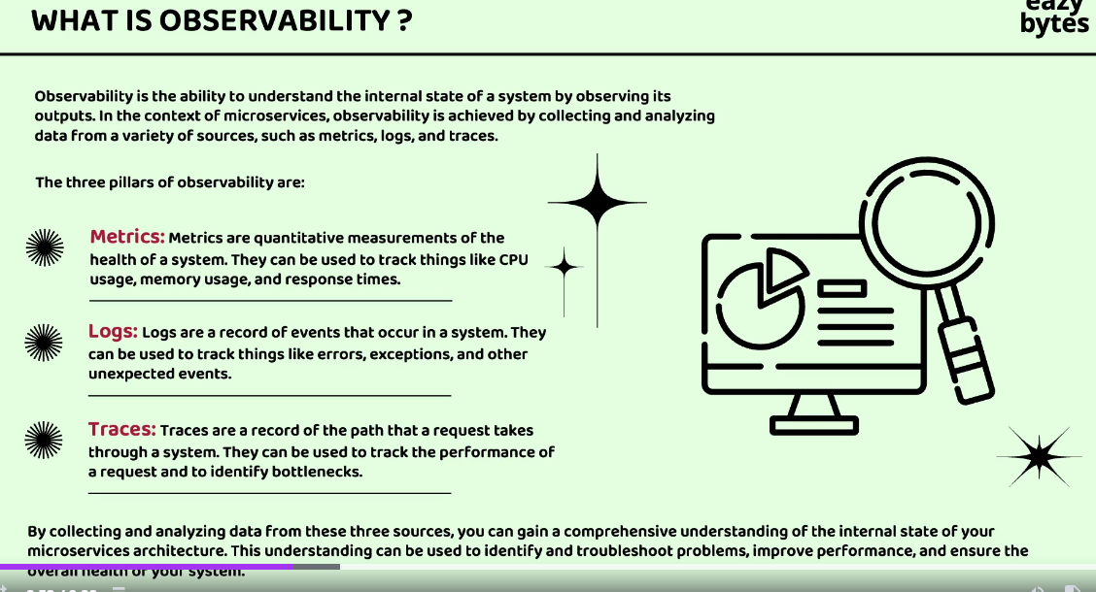

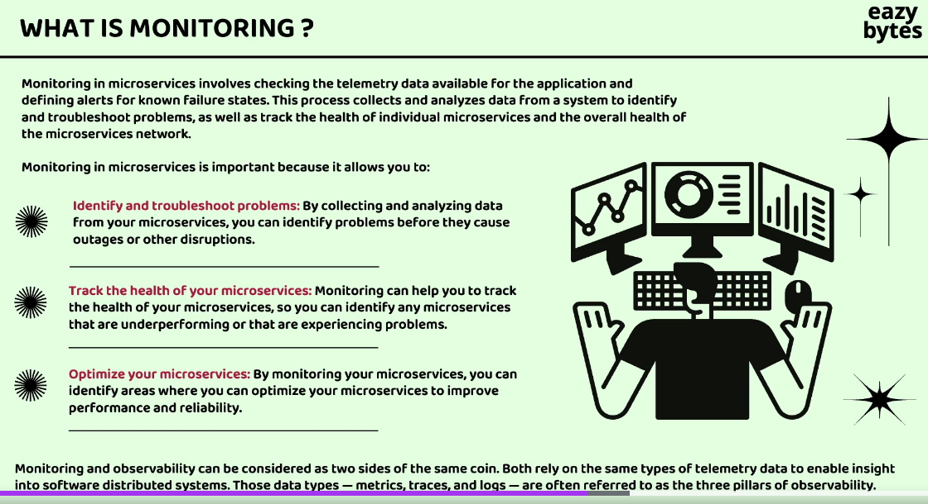

In simple words say if a container has high CPU usage then we monitor it and increase the number of instances.

Say we see some request have null pointer exceptions we analyze the logs and find the scenario, this is observability

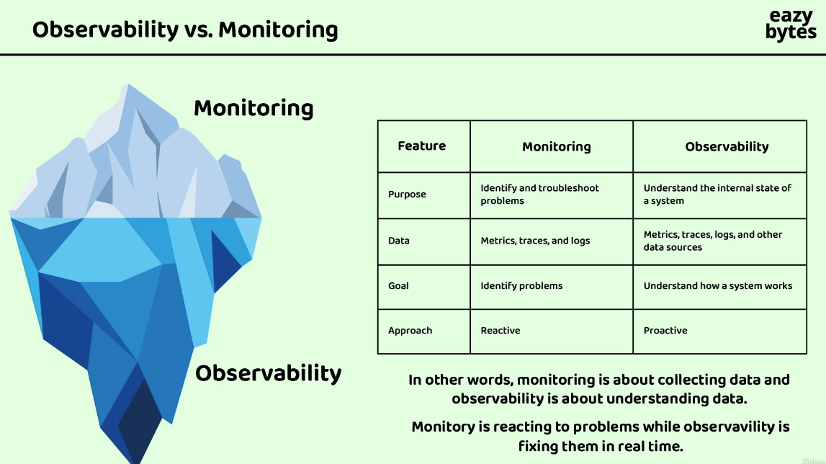

## Distributed tracing

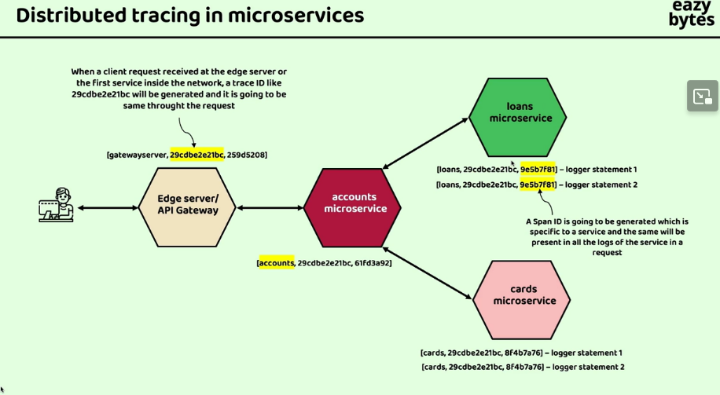

Grafana provides a lot of solution for distributed tracing with Loki and promtail

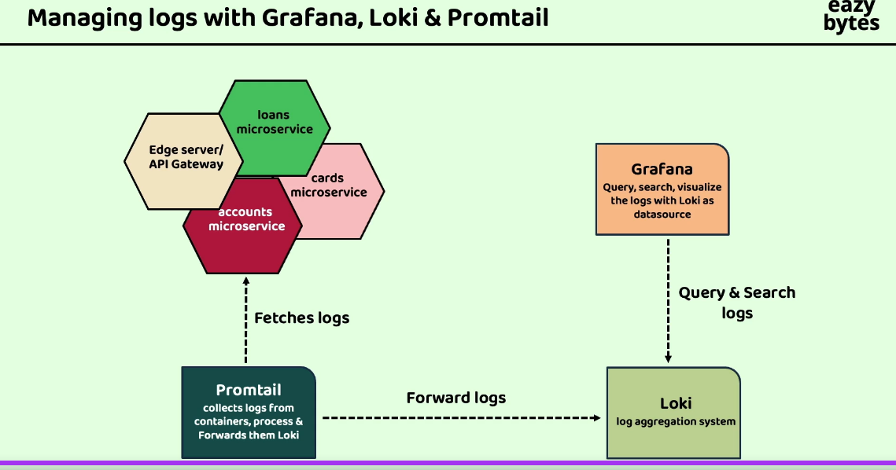

Grafana connects with loki for logs using data sources defined in the docker compose

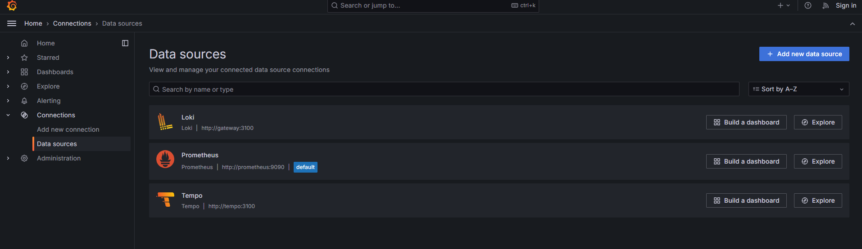

# Orchestration

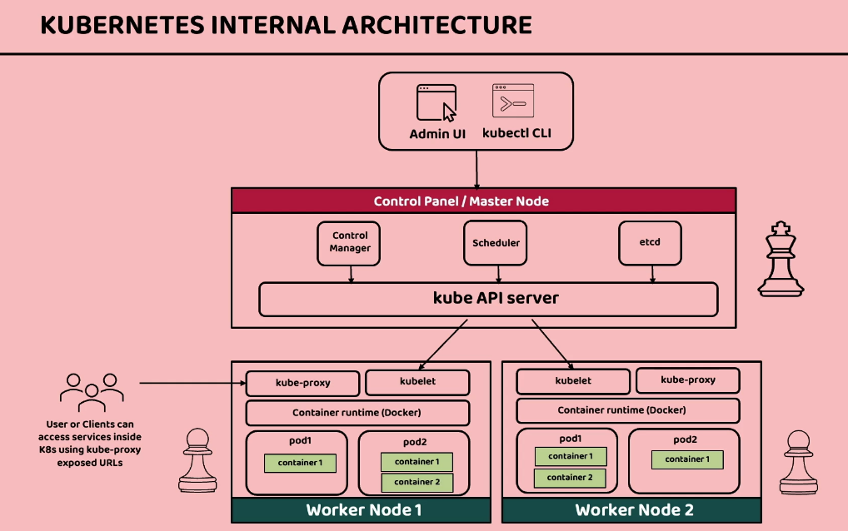

Master node - For controlling worker

Kube API server- It will expose API to interact with outside world also used to interact between master and worker nodes

Kubectl CLI/ Admin UI – Provide input to API server in master node using YAML file

Scheduler - Takes input from API server which will help to identify to which worker node the changes has to be done

Control Manager - Monitor the health status of worker nodes and replace them in case of any error and kills/bring up new nodes if required

etcd - DB/Storage for the status of workers

Worker node - responsible for sending traffic to microservice

Kublet - Agent running in worker through which worker connects and execute instructions

Container runtime- Docker or some docker like containerization tool

Pod - Smallest deployment unit. Always contain a single microservice unless in very rare scenario a helper container is needed

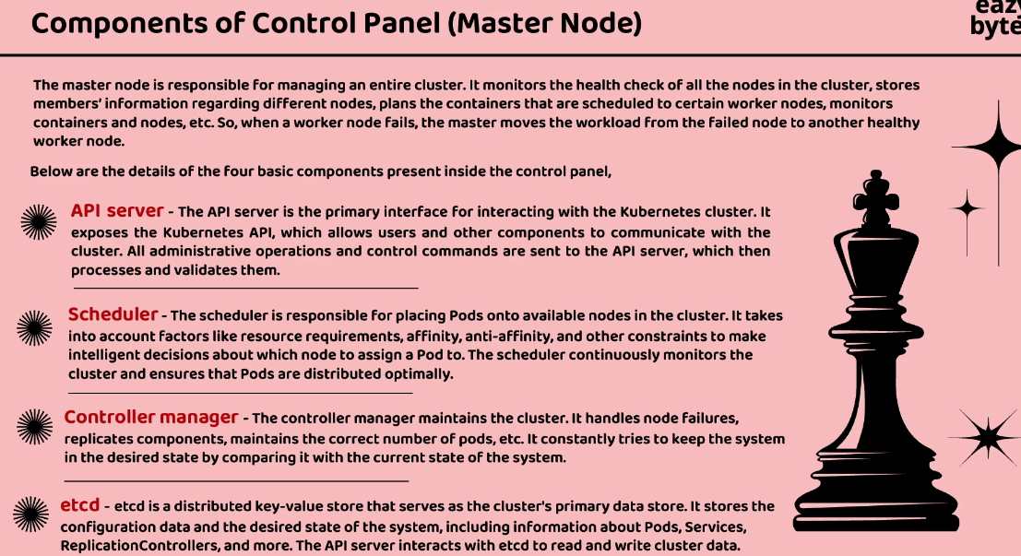

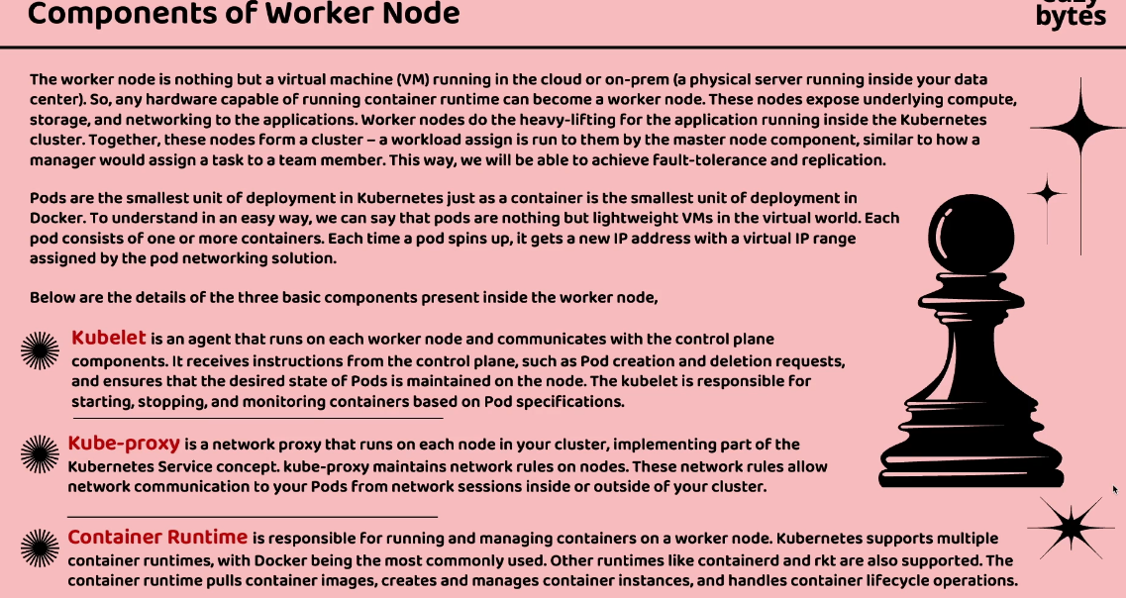

kubectl config get-contexts

kubectl config get-clusters

kubectl config use-context docker-desktop

kubectl get nodes

Kubernetes dashboard is not included by default and we need to set it up first from the helm. So install helm first then add dashboard using below commands

helm repo add kubernetes-dashboard https://kubernetes.github.io/dashboard/

helm upgrade --install kubernetes-dashboard kubernetes-dashboard/kubernetes-dashboard --create-namespace --namespace kubernetes-dashboard

Once started we have to do port forwarding

kubectl -n kubernetes-dashboard port-forward svc/kubernetes-dashboard-kong-proxy 8443:443

We can access dashboard <https://localhost:8443/#/logi>

Now need to create admin user by creating a file dashboard-adminuser.yaml

apiVersion: v1

kind: ServiceAccount

metadata:

name: admin-user

namespace: kubernetes-dashboard

And run command

kubectl apply -f dashboard-adminuser.yaml

Next have to do role binding create file and run kubectl apply -f filename.yml

apiVersion: rbac.authorization.k8s.io/v1

kind: ClusterRoleBinding

metadata:

name: admin-user

roleRef:

apiGroup: rbac.authorization.k8s.io

kind: ClusterRole

name: cluster-admin

subjects:

- kind: ServiceAccount

name: admin-user

namespace: kubernetes-dashboard

kubectl -n kubernetes-dashboard create token admin-user

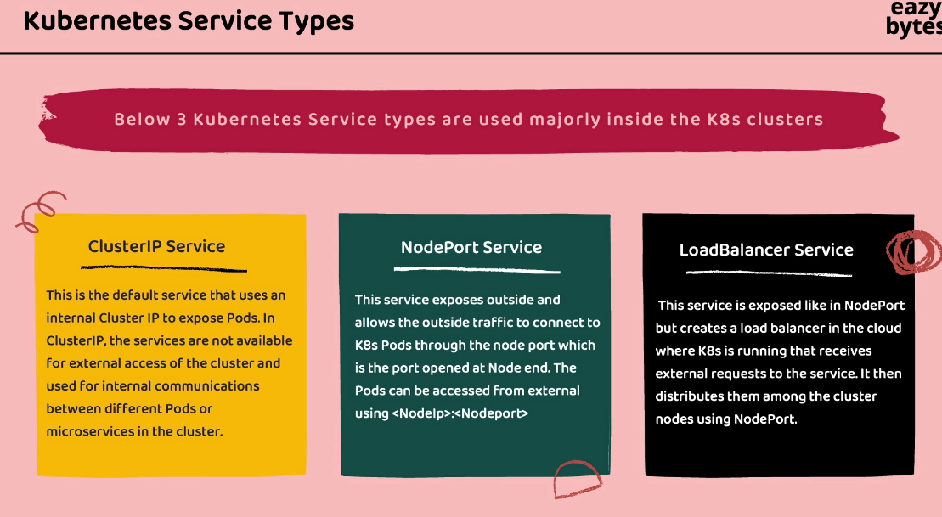

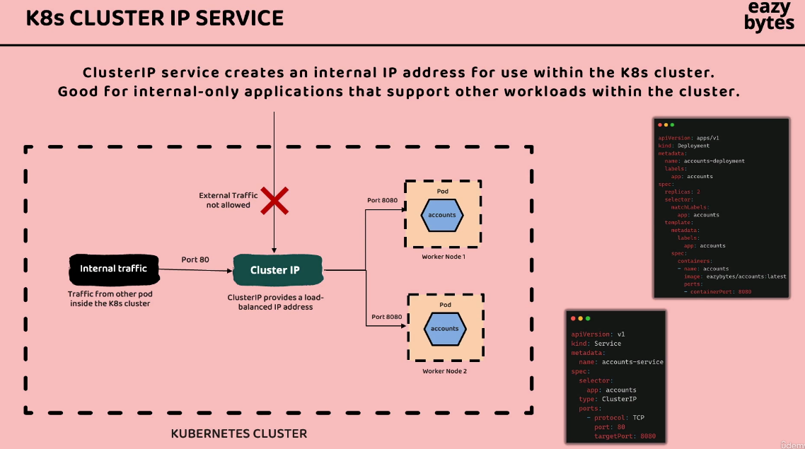

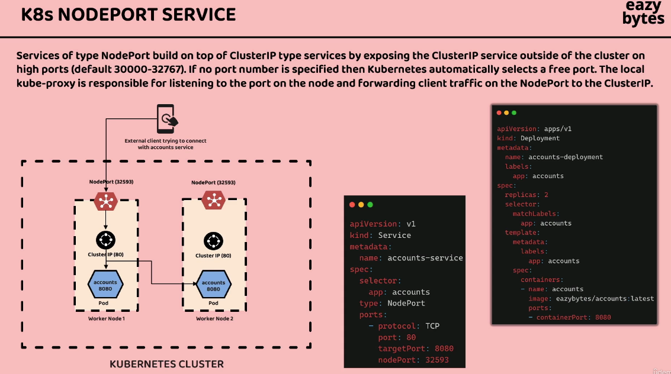

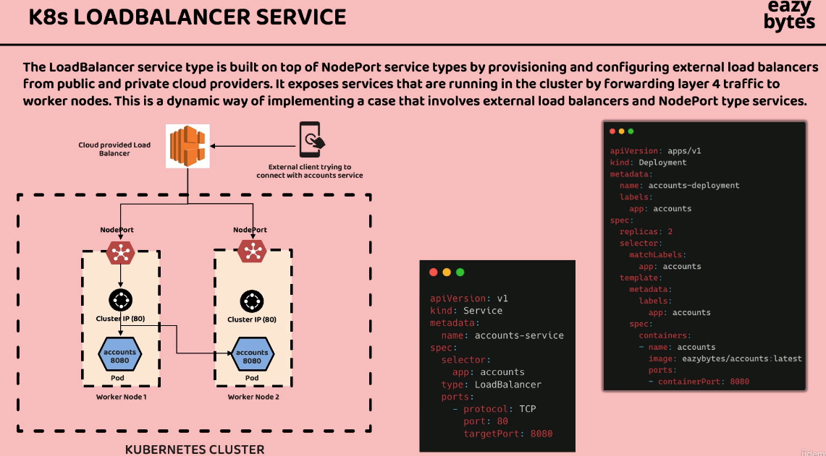

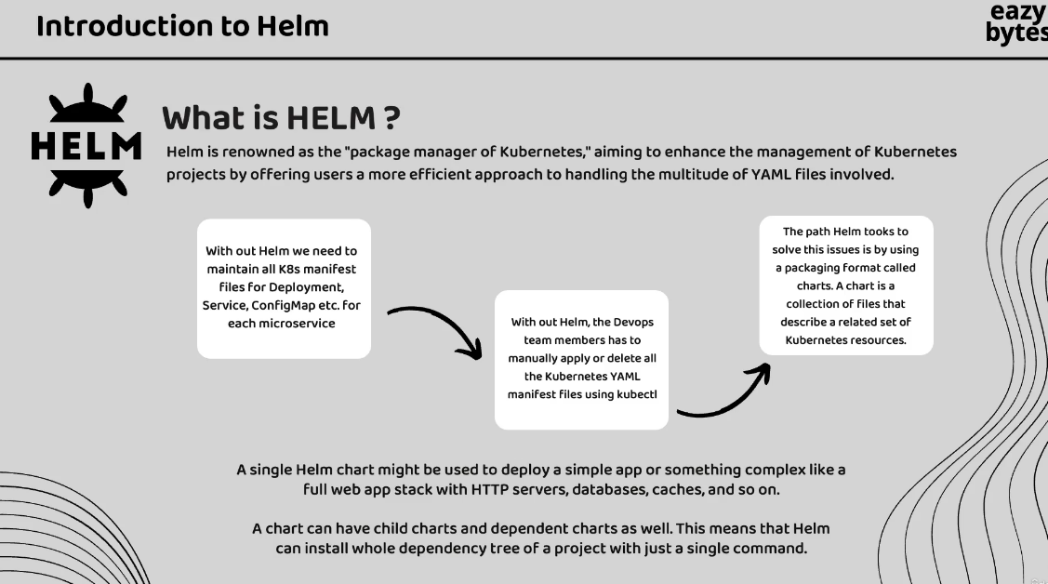

A lot of values are same here

